James Zartman
METC143
4/26/17

Problem Statement:
The task is to design a cable that will support a 60-ton vehicle. The cable is 25-foot-long and can have an elastic deformation of no more than 10%. Using the Modulus of Elasticity for various metals design a cable. Using standard cable diameter sizes.
Introduction:
The process that I used to calculate the stress for the common cable diameters was to use the equation for stress. That equation is stress is equal to the force divided by the cross sectional area. The force was given as 60 tons, which was the same force used to figure out the stress for all the sizes. To figure out the cross-sectional area I used the (pi *diameter^2)/4 since the common cable sizes were given in diameter and figured out the area for all the cable sizes. Now knowing all the cross-sectional areas and the force being a constant for all the sizes I could solve the equation for the sizes by taking the force divided by the solved for cross sectional areas of all the sizes. That gave me stress but was in tons per inches squared and I needed to get to pounds per inches squared (PSI). Since 1 ton is equal to 2000 pounds I took all the calculated stresses for each cable size and multiplied them by 2000 to get the stress into PSI.
To calculate the diameter of cable needed I used the equation for the modulus elasticity. That equation is modulus elasticity equals stress divided by strain. Since the only known value of the equation was the modulus elasticity I had to solve for stress and strain. I solved for strain first since we knew the initial length of the cable, 25ft. Also had to solve for 10% elastic deformation of the cable to figure out the maximum amount of stretch the cable could have. Since this measurement was in in feet and needed it to be in inches I converted it to inches by taking 25 times 12 to get 300 inches. I then took 300 times 1.1 and that gave me 330 inches which was 10 percent increase in length. Now that the initial and final length of the cable were known I could then solve for strain. The equation for strain was the (final length minus the initial length)/initial length, which came to .1 and is the strain for all 4 materials since the length is the same regardless of the material. Now since the modulus elasticity and strain are known, I rearranged the modulus elasticity equation to get stress by its self by multiplying both sides of the equation by strain. That left stress by itself equal to modulus elasticity times strain. Using the modulus elasticity given for each material I solved for the stress of each material. Now that we know what the stress is I could figure out the diameter. I did this by taking the above mentioned equations for stress, where stress equals force divided by cross sectional area. I had to rearrange the equation to be able to solve for area. I multiplied both sides by area and then divided both sides by stress. That left me with area equal to force divided by stress. I solved for area of all 4 materials. Using the equation $A=πr^{2}$ I could figure out the radius by rearranging to equation to solve for radius which is $\sqrt{A∕π}$. Once solving for the radius of all 4 materials I then took the radiuses and multiplied them by 2 to get the diameter. Then taking the solved diameter and figuring out the closest common size of cable that was bigger.
To calculate the thermal expansion of each material I used the equation for thermal expansion. That equation is Thermal expansion equals the thermal coefficient of material multiplied by the length multiplied by the change of temperature. And used this for all 4 materials in 20 degree intervals.
Results:
Material Information
2014 T6-Aluminum |  | 1045 Steel |  | Copper |  | Titanium Ti-6Al-4V (Grade 5), Annealed
component | Percentage | Component | Percentage | Component | Percentage | Component | Percentage
Aluminum, Al | 90.4 - 95 % | Carbon, C | 0.42 - 0.50 % | Copper, Cu | 100% | Aluminum, Al | 5.5 - 6.75 %
Chromium, Cr | <= 0.10 % | Iron, Fe | 98.51 - 98.98 % |  |  | Carbon, C | <= 0.080 %
Copper, Cu | 3.9 - 5.0 % | Manganese, Mn | 0.60 - 0.90 % |  |  | Hydrogen, H | <= 0.015 %
Iron, Fe | <= 0.70 % | Phosphorous, P | <= 0.040 % |  |  | Iron, Fe | <= 0.40 %
Magnesium, Mg | 0.20 - 0.80 % | Sulfur, S | <= 0.050 % |  |  | Nitrogen, N | <= 0.030 %
Manganese, Mn | 0.40 - 1.2 % |  |  |  |  | Other, each | <= 0.050 %
Other, each | <= 0.05 % |  |  |  |  | Other, total | <= 0.30 %
Other, total | <= 0.15 % |  |  |  |  | Oxygen, O | <= 0.20 %
Silicon, Si | 0.50 - 1.2 % |  |  |  |  | Titanium, Ti | 87.725 - 91 %
Titanium, Ti | <= 0.15 % |  |  |  |  | Vanadium, V | 3.5 - 4.5 %
Zinc, Zn | <= 0.25 %

Calculated Diameter for each material
Aluminum- ½”
Steel- 1/4”
Copper- 3/8”
Titanium- 3/8”

Calculations for stress of all Common Diameter sizes of cable

Dia. of cable (inches) | cross sectional area(in^2) | Stress (tons/in^2) | Stress (psi)
1/64 | 0.0002 | 312911.35 | 625822701
1/32 | 0.0008 | 78227.83763 | 156455675.3
1/16 | 0.0031 | 19556.95941 | 39113918.81
1/8 | 0.0123 | 4889.239852 | 9778479.704
3/16 | 0.0276 | 2172.99549 | 4345990.979
1/4 | 0.0491 | 1222.309963 | 2444619.926
3/8 | 0.1104 | 543.2488724 | 1086497.745
1/2 | 0.1963 | 305.5774907 | 611154.9815
3/4 | 0.4418 | 135.8122181 | 271624.4362
1 | 0.7854 | 76.39437268 | 152788.7454
1 1/4 | 1.2272 | 48.89239852 | 97784.79704
1 1/2 | 1.7671 | 33.95305453 | 67906.10905
1 3/4 | 2.4053 | 24.94510128 | 49890.20257
2 | 3.1416 | 19.09859317 | 38197.18634

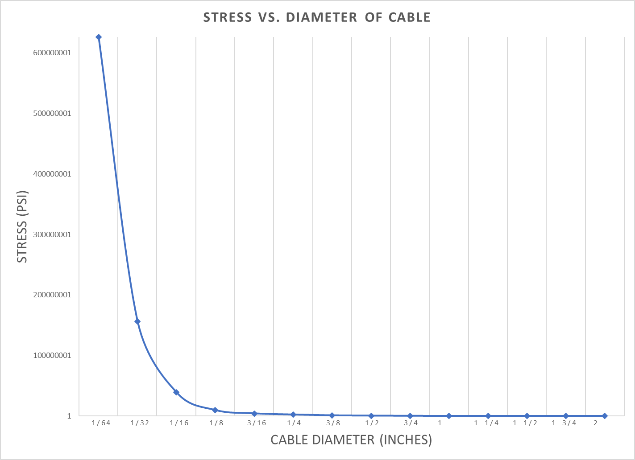
Stress Vs. Diameter Plot

Fatigue Analysis:
Stress calculated for the calculated diameters for aluminum and steel.
- Aluminum was ½” diameter cable and the calculated stress for ½” cable was 611154.9815 psi
- Steel was ¼” diameter cable and the calculated stress for ¼” cable was 2444619.926 psi
According to these calculated stresses neither one of these cables would last any cycles
Thermal Analysis:
Calculated Thermal expansion for each material
 | Aluminum | Steel | Copper | Titanium
Coefficient of Thermal Expansion | 1.31E-05 | 7.22E-06 | 1.03E-05 | 5.39E-06
change in temperature | Change in length (inches)
300 | 1.179 | 0.6498 | 0.927 | 0.4851

Change in Temperature vs. Change in length

Conclusion:
If I had to choose a diameter for each material I would use at least 1.5” diameter cable for steel and 1.75” cable for aluminum. For these two materials, I am choosing these diameters based off the fatigue charts for steel and aluminum. At 1.5” for steel and 1.75” for aluminum the cable would at least last 100000 cycles which would be beneficial if we needed to hold 60 tons’ multiple times without it breaking. For copper and titanium based off the calculations I would have to say that the size needs to be at least 1.75” as well to be able to withstand multiple loads and cycles.
I would choose to make the cable out of steel because it the cost would be cheaper since the size is smallest out of all the materials.

